Block Chain Demo

Ryan Scott

Grand Canyon University  
ITT-306 Information Security II

Prof. Christine Bakke

## Hashes

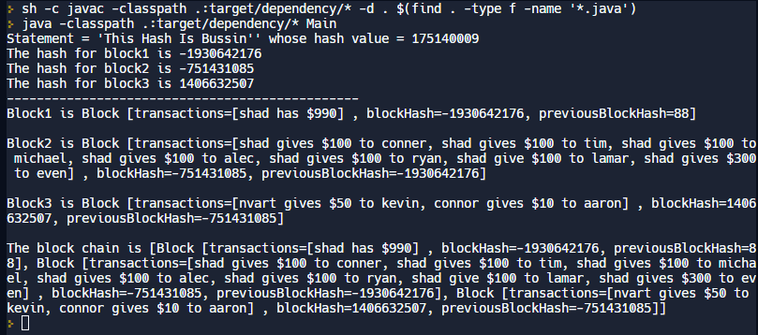

Example Hash 1

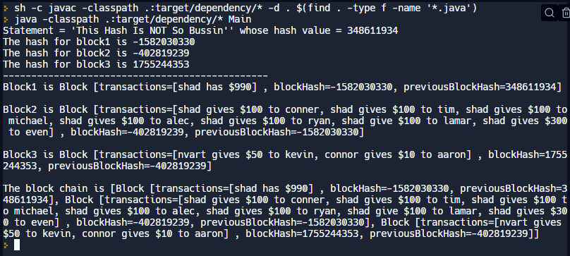Example Hash 2

## Fraud

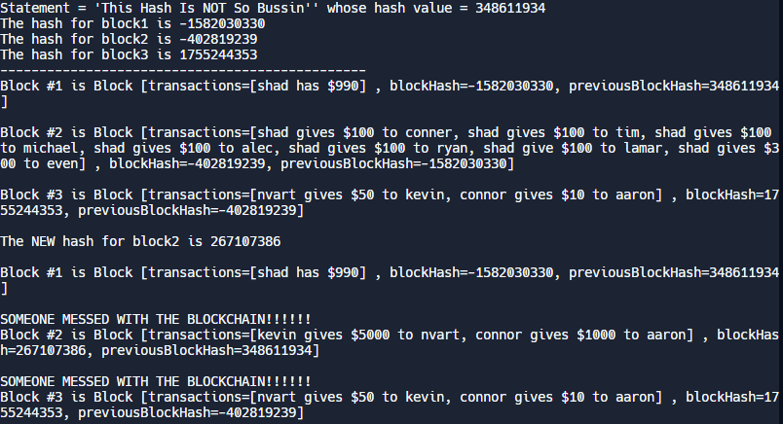

## The program correctly identifies the problem in the blockchain, starting at the fraudulent point.

## 

## Conclusion

Hashing is a way to turn any type of data into a short, unique code called a hash. In a blockchain, each block of data is linked to the previous one using its hash, creating an unbroken chain. If anyone tries to change the data in one block, it will change the hash of that block and every subsequent block, making the tampering immediately noticeable to all participants in the blockchain network. This makes the blockchain secure and resistant to unauthorized changes, (Programming w/ Professor Sluiter, 2020).

Hashing is a crucial aspect of how blockchain works because it ensures the integrity and immutability of the data stored within it. By creating a unique and irreversible digital fingerprint for each block, it provides a secure and transparent way to store and transfer valuable information without the need for intermediaries, (Programming w/ Professor Sluiter, 2020).

# References

Programming w/ Professor Sluiter. (2020, June 11). *Program a Blockchain example with Java code example* [Video]. YouTube. <https://www.youtube.com/watch?v=igedHOpSqu4>